Assignment – 02

Syed Arham Hussain

Abstract:

In this assignment, we have used the World Bank’s comprehensive data set that provides us with climate change indicators for countries all over the world. In this analysis, we explore some of the indicators related to climate change and examine their statistical properties and relationships, by first ingesting and then manipulating the dataset which was later transformed and cleaned for easier analysis. We examined the statistical properties of several climate change indicators. Through our analysis, we identified several key findings including the increasing trend of CO2 emissions and access to electricity over time, and the correlations between indicators by using appropriate visualization tools and statistical methods.

Repository Link:

<https://smallpdf.com/word-to-pdf>

**Analysis on The World Bank Data:**

For the analysis of this dataset, we have selected several indicators against different countries for a diverse period such as, some of the analyses are made on a range between 2016 to 2021, some are done particularly on a year etc., we have used indicators such as, CO2 emissions (kt), Access to Electricity (% of population), Total greenhouse gas emissions (kt of CO2 equivalent), CO2 emissions from liquid fuel consumption (kt), Renewable energy consumption (% of total final energy consumption), Electricity production from natural gas sources (% of total). The analyses show how each indicator changed or remain same w.r.t time.

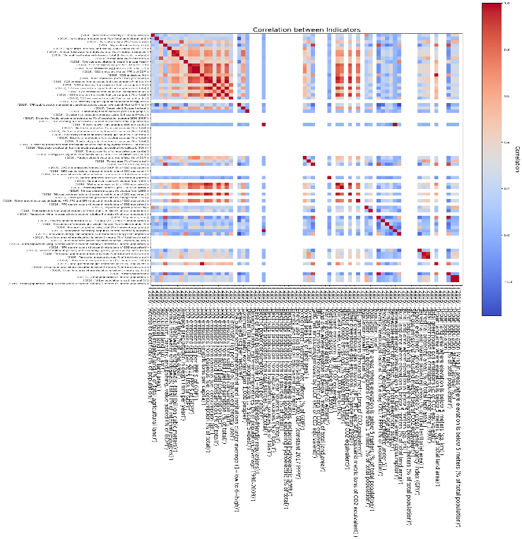

This shows us the between each indicator with every other indicator, the blue shows the negative correlations while the red shows positive correlations between the indicators, while white shows no correlation, this is showing that Urban Population is positively correlated with GHG net emissions/removals by LUCF (Mt of CO2 equivalent), while it’s negatively correlated forest area (sq. km).

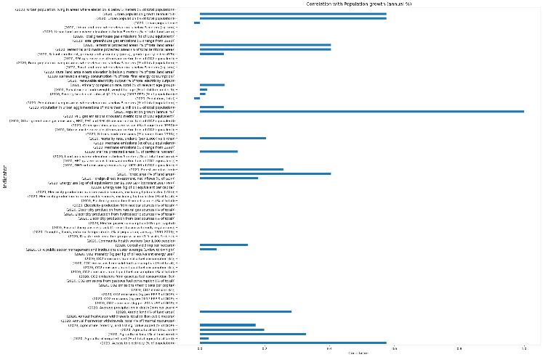

Another correlation graph shows correlation of each indicator with Population growth (annual %) and it shows that Urban population growth (annual %) is positively correlated with the total annual population growth.

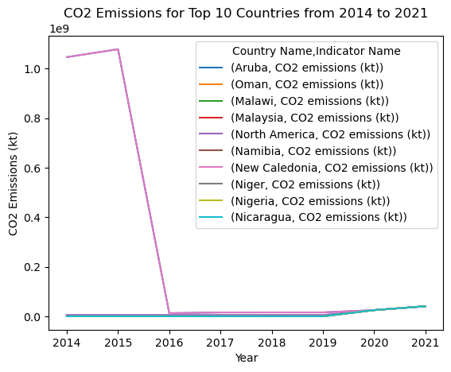

This plot shows us that New Caledonia topped in CO2 emission in 2015 which dropped significantly in the next year i.e., 2016, while other countries had already started taking care of this and didn’t show any significant spikes.

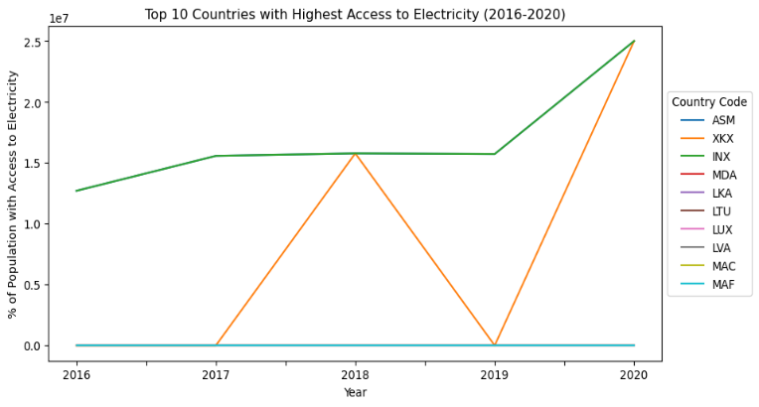

Shows the spike along with continuity of INX (Non-Classified) and XKX (Kosovo) countries on the maximum consumption of electricity between the period of 2016 till 2020 while others kept their consumption less that can be highly correlated with their establishment and success in the world during these times.

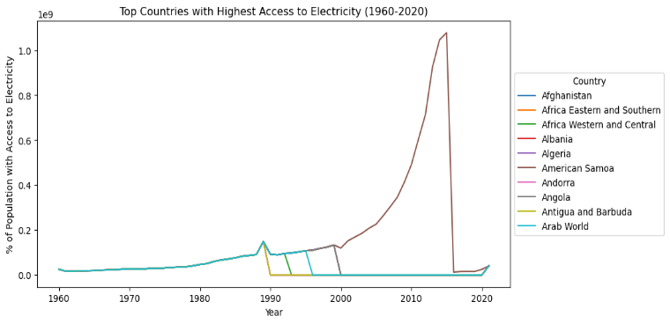

On the other hand, if we increase the horizon, it is clear that each other country started consuming electricity that initially was led by Arab World till 1990, which later found to be decreased while countries like American Samoa had clearly seen a spike in 2010 leading to their plants and country’s establishment in the country during those times.

It is evident that several countries have contributed to the gas emission of between 2016 to 2021 which is related to their population. The world till 2019 was contributing to this but faced a significant fall while Hong Kong and Aruba started their contribution slowly in 2016 and then faced a huge spike in the emission.

This shows the greenhouse gas emission particularly in the 2019 where World made a huge contribution to the gas emission in which is followed by IBT, LMY, MIC and lastly IBD.

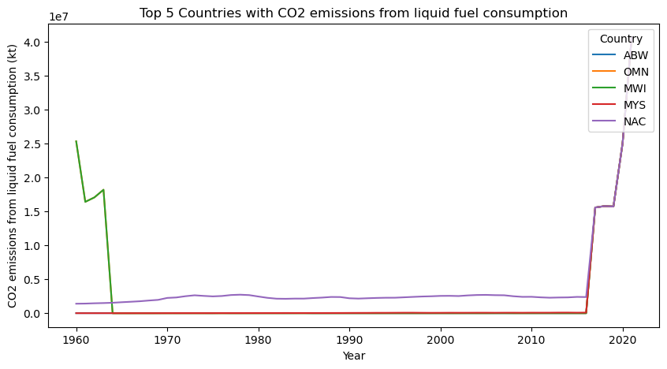

This shows the top countries with their CO2 production from their consumption of liquid fuel from 1960 till 2020. Malawi reduced their CO2 production before 1970 while countries like Oman, Malaysia, North America kept their production low but after 2010 NAC, MYS showed extreme high production which is related to their increased GDP’s performance but lack of trees as deforestation increases the emission.

Countries like Aruba, Oman, Malaysia, Malawi, and North America all shared an identical responsibility in the generation of electricity from natural gases available to them. The contribution was minimal between 2017 to 2019 but then they increased their production tremendously altogether.

The above is evident from this visual as well that each of these countries shared equal role in the production of electricity from natural gas.

Renewable energy consumption is seen to be increasing worldwide from 1960 to 2020, global renewable energy consumption increased by around 270%, while non-renewable energy consumption increased by only 50%. This indicates a global shift towards cleaner energy sources.